Did simulations with a simplified setting, for $i=1,…,100$ (sample size: 5,000):

* X ~ N(0, 1); Logit(P(Y=1)) = 1 + 2 \* X
* Fit the model using X and Y and we call this model $m_{i}$.
* Repeat the following procedure for 100 times:
  + External X ~ N(0,1); Logit(P(External Y=1)) = 1 + 2 \* X
  + Obtain the estimates of calibration slope and intercept
* Take the average of the estimates and use the average values as the true value of model calibration slope and intercept
* Repeat the following procedure for 100 times:
  + External X ~ N(0,1); Logit(P(External Y=1)) = 1 + 2 \* X
  + Obtain the estimates of calibration slope and intercept and their standard error
  + Construct 95% CIs based on the point and standard error estimates and check if the true value falls in the CIs
* Take the average of the standard error estimates and calculate the sample standard deviation of the point estimates; calculate % of times when the true value falls in the CIs as the empirical coverage probability

Now we have fit 100 different models and for each model, we have a formula-based standard error estimate, an empirical standard error, and an empirical coverage probability for calibration slope and intercept, respectively

Relative difference between formula-based standard error and empirical standard error for calibration slope:

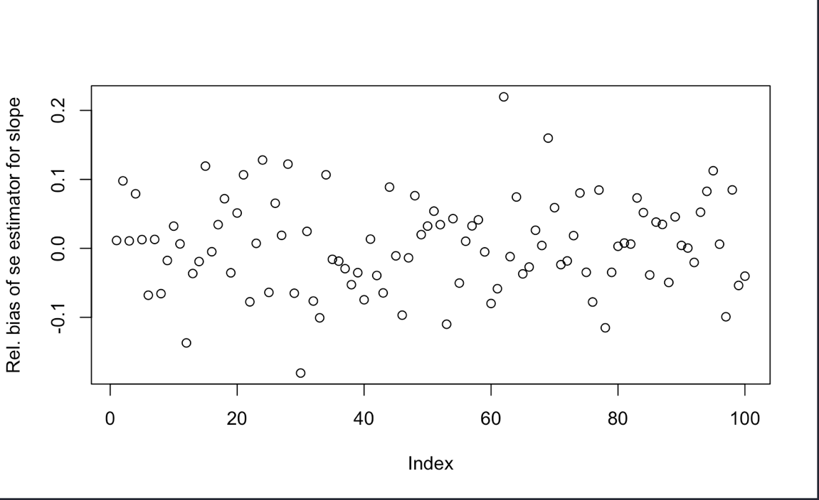

Relative difference between formula-based standard error and empirical standard error for calibration intercept:

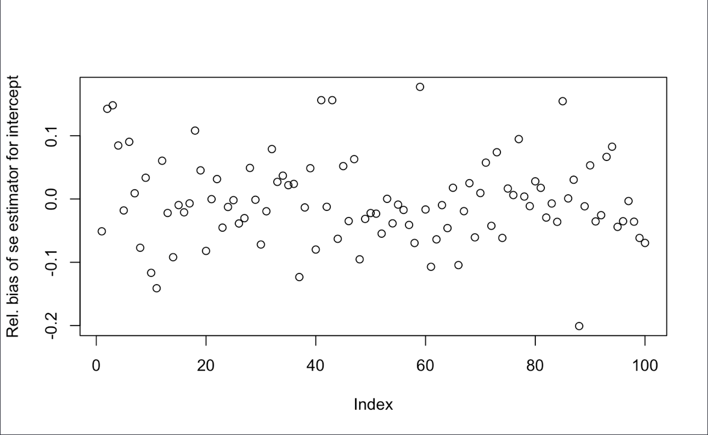

Box-plot of coverage probability for calibration slope (mean value 0.9447):

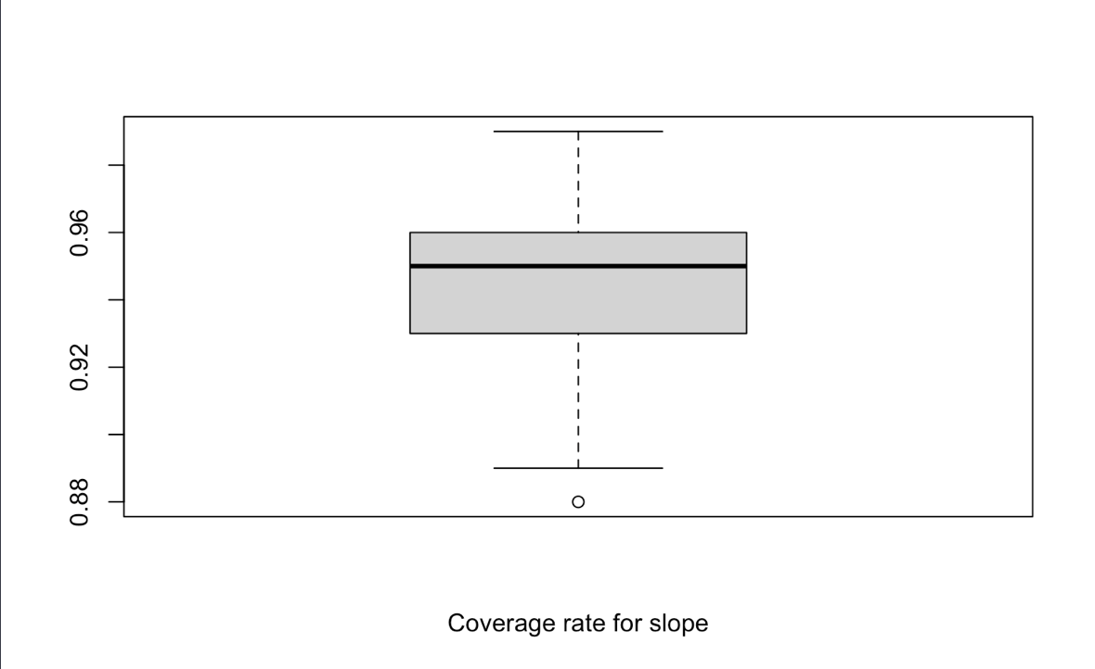

Box-plot of coverage probability for calibration intercept (mean value 0.9505):

